**Course-End Project**

**Automated AWS Lambda Deployment**

Steps to be followed:

1. Create and clone a Git repository
2. Set up the Cloud9 environment
3. Configure and execute the CodePipeline
4. Test and validate the functionality

**Step 1:** **Create and clone a Git repository**

1. Navigate to the GitHub dashboard, click on **New** under the Repositories section, enter the repository name and optional description, then click **Create repository**

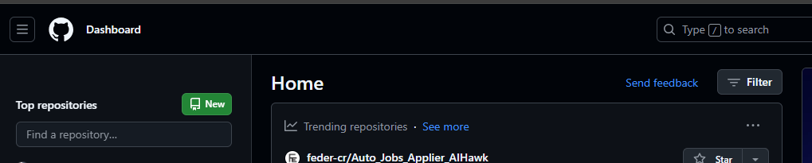

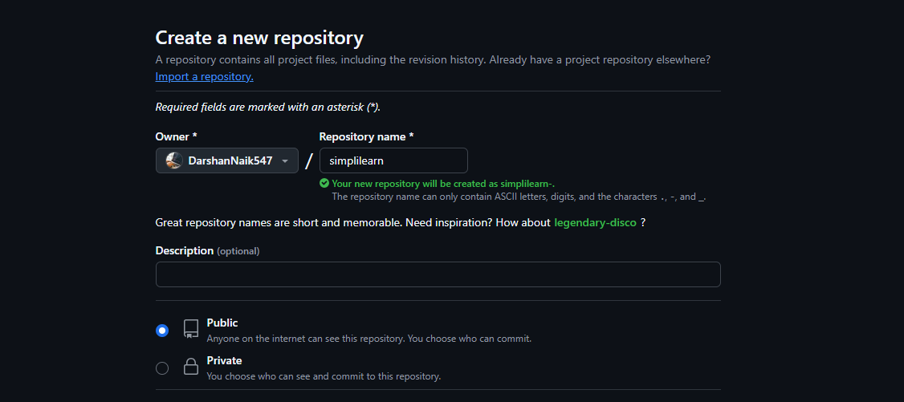

* 1. Navigate to GitHub, select the repository from your repositories list, and click on the **Code** button to display its URL. Copy the **HTTPS** link provided to clone the repository to your local machine using your Git client.

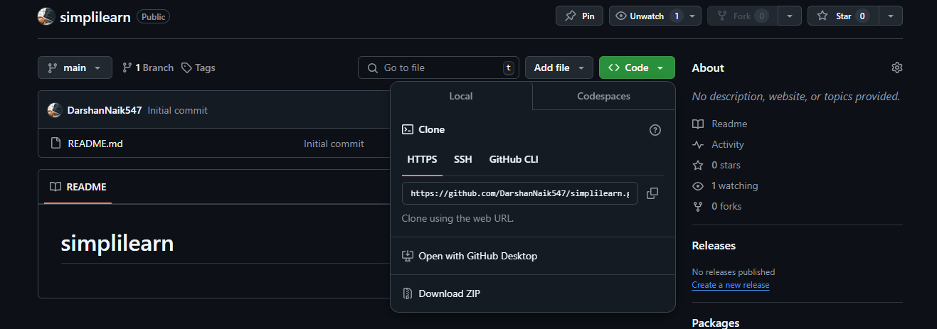

**Step 2: Set up the Cloud9 environment**

* 1. Navigate to the AWS management console, select the AWS Cloud9 service under Developer Tools, and click the **Create environment** button to set up a new Cloud IDE for writing, running, and debugging your code

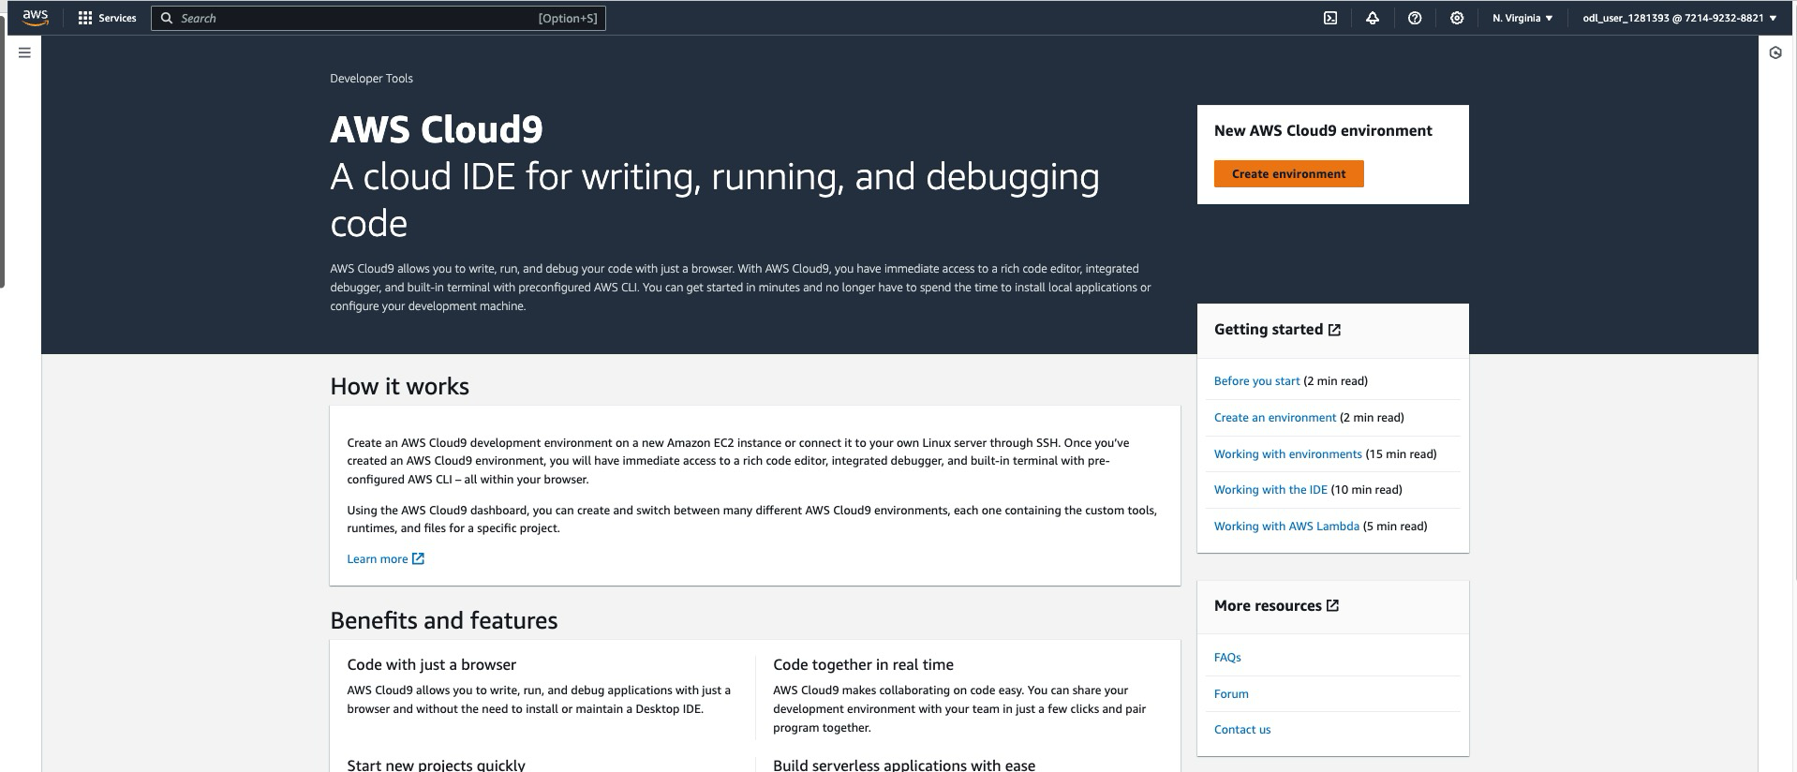

* 1. Navigate to the AWS Cloud9 **Create environment** page to enter a name and optional description for your new Cloud9 IDE, choose to run it on a new EC2 instance or an existing server, and select from various EC2 instance types depending on your project requirements

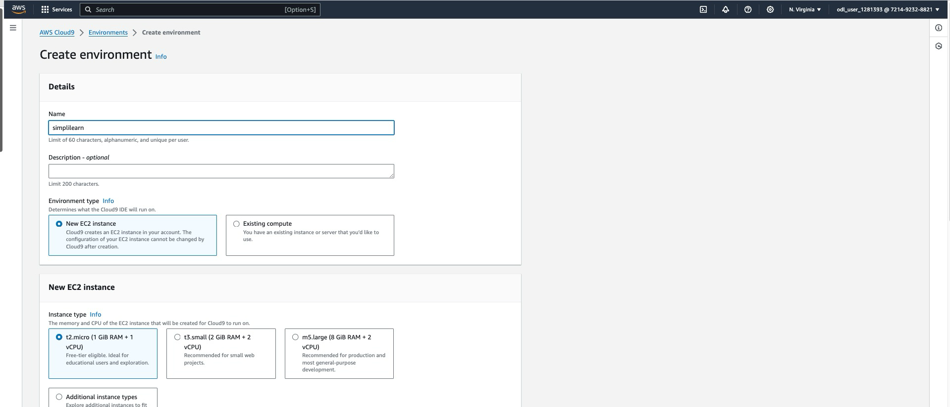

* 1. Go to the AWS Cloud9 Environments page, where you can view the newly created environment named **simplilearn**, select it to open or manage settings, and click on **Open** **in Cloud9**, or use **View details** to see more information about the environment settings and configuration

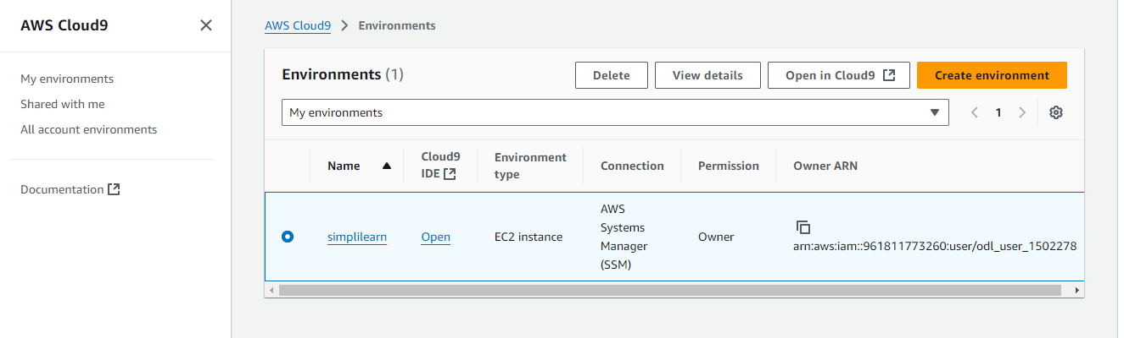

* 1. Access the AWS Cloud9 IDE interface to customize settings such as theme and key bindings through the sidebar, use the AWS toolkit for enhanced functionality, and begin coding directly in the integrated terminal

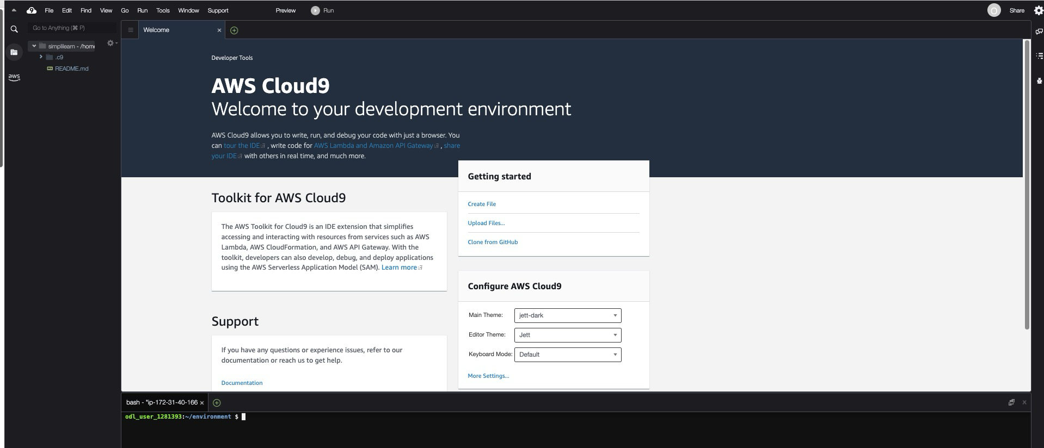

**Note**: In Cloud9 IDE, run the **git clone** command copied from the GitHub repository page

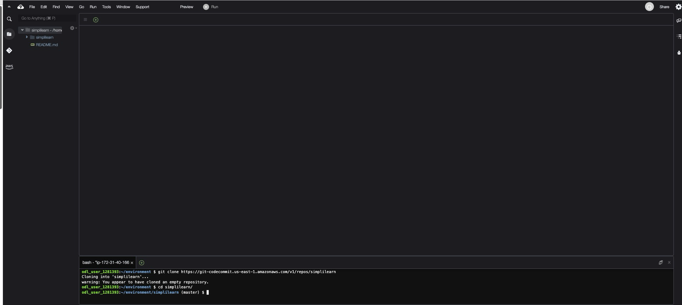

The screenshot shows the GitHub repository interface for Simplilearn, which contains files such as **buildspec.yml**, **lambda_function.py**, **requirements.txt** and **template.yml**. You can manage these files directly through the GitHub web interface.

**Note:** Refer to this code as an example: [**https://github.com/ramkrishnatest/lambdapi.git**](https://github.com/ramkrishnatest/lambdapi.git)

**Step 3: Configure and execute CodePipeline**

**Note:** After copying the code from GitHub to the Cloud9 environment, push it to AWS from the Cloud9 IDE, then proceed to create a build project using AWS CodeBuild

1. Access the **Create build project** page in AWS CodeBuild, specify the project name, select GitHub as the source provider, choose your repository and branch from the dropdown menus, and then configure additional settings as needed to initiate the build process

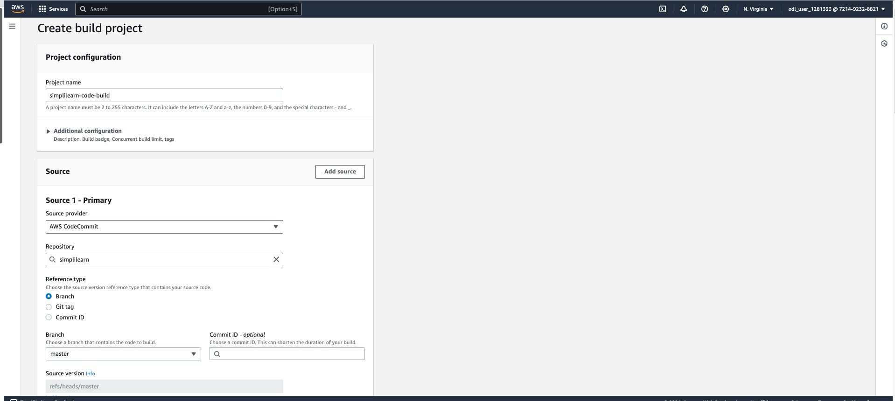

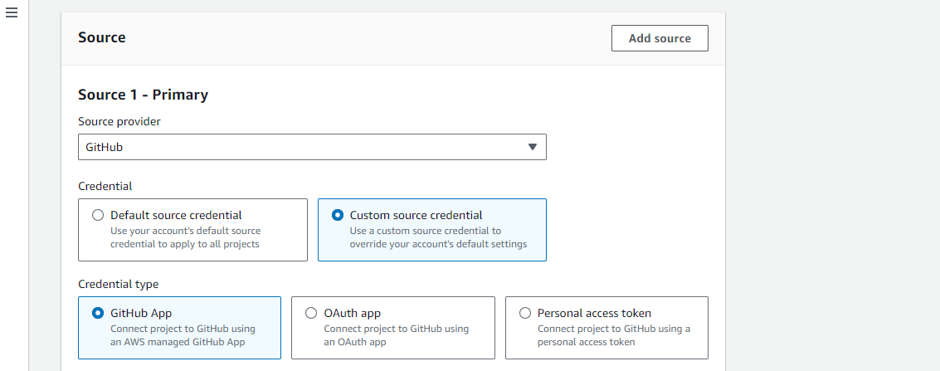

1. Select **Managed image** with Amazon Linux as the OS and **Standard** runtime on the Environment configuration page, choose **EC2** or **Lambda** for Compute, and decide on a new or existing service role for permissions

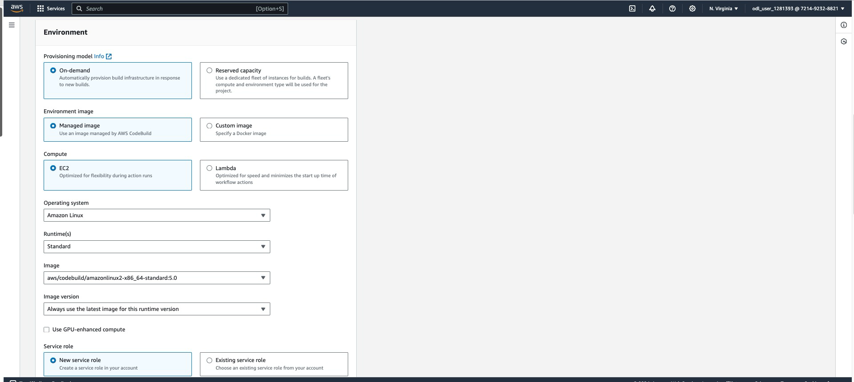

Simultaneously, create an S3 Bucket for saving the artifact, which is used in the **buildspecification**

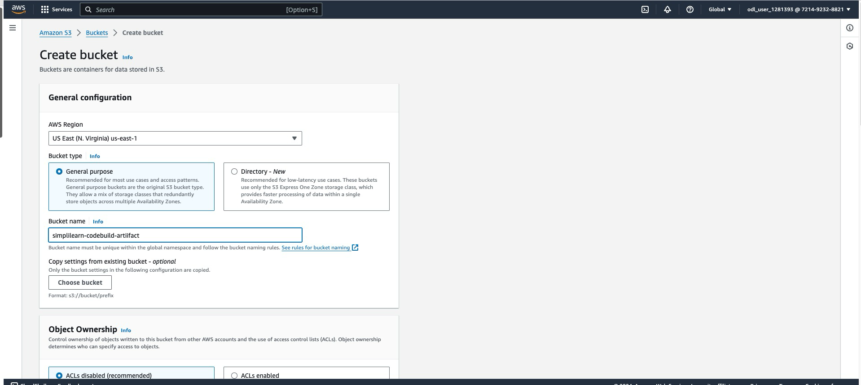

Go back to the AWS CodeBuild and complete the build creation

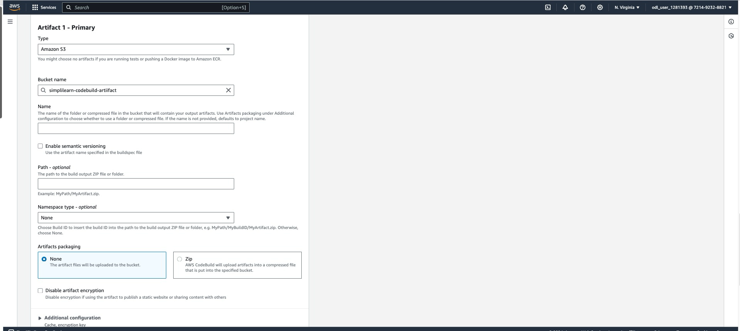

1. Run the build to test the build success or failure; try to troubleshoot in between

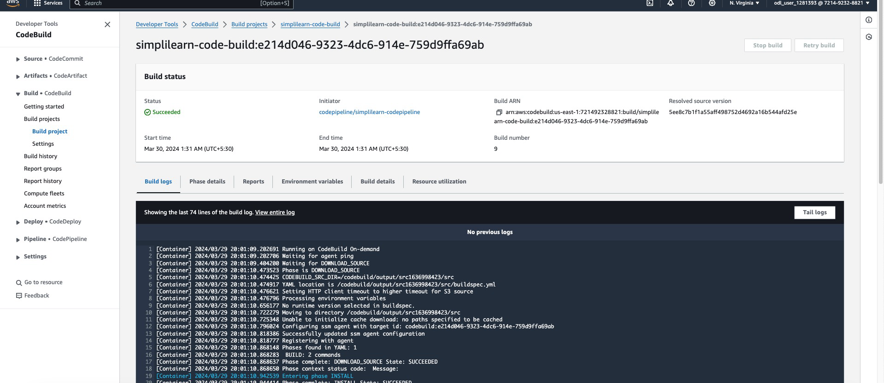

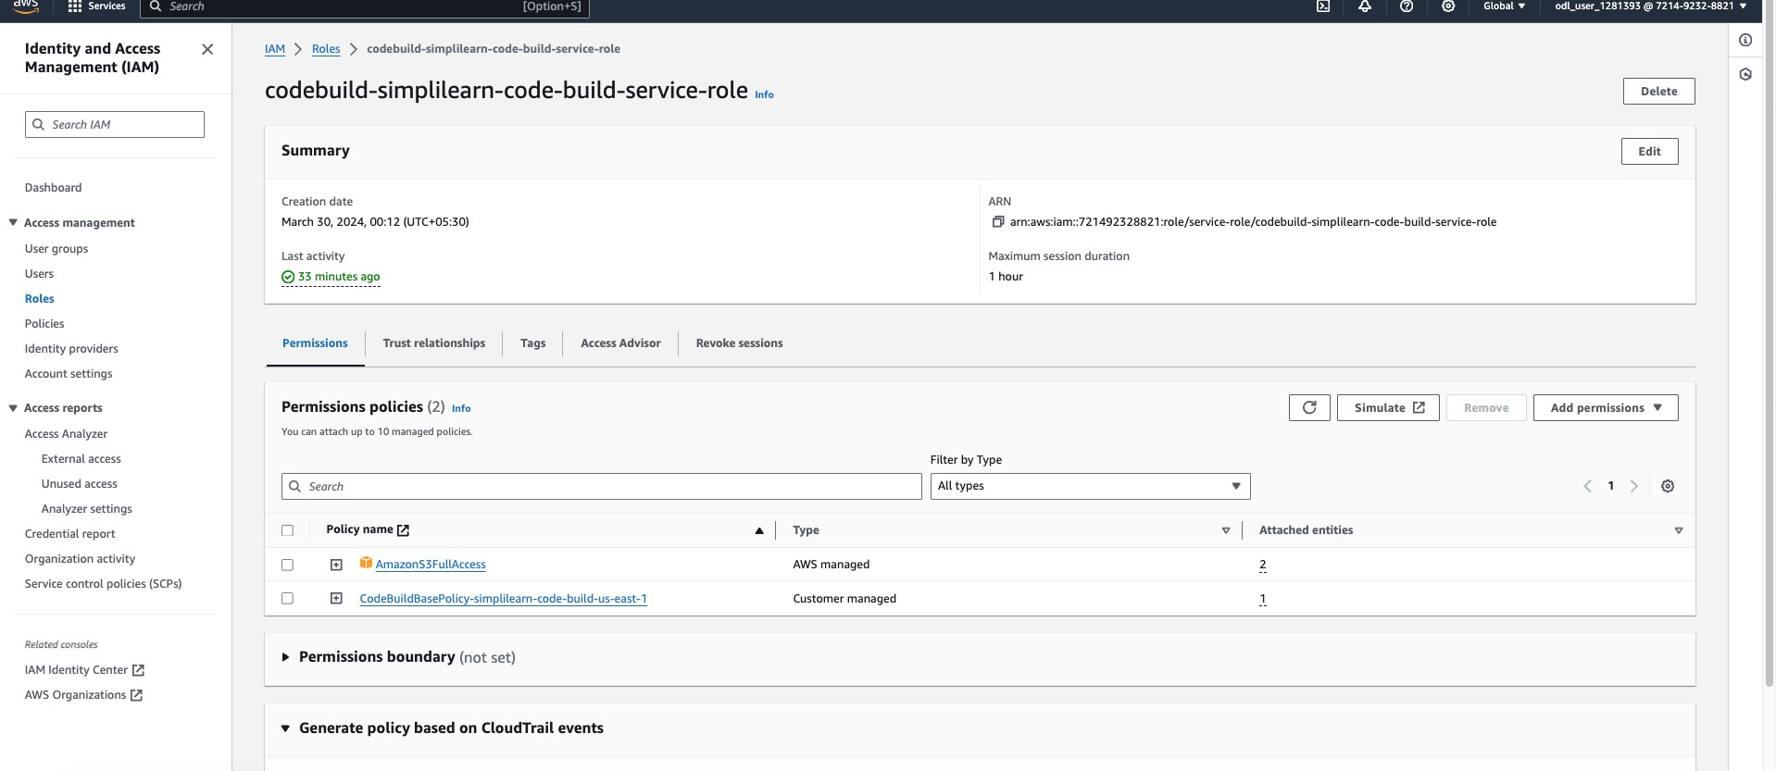

1. Go to the Create new pipeline page of AWS CodePipeline service, enter your pipeline name, select **New service role**, and choose the execution mode for your pipeline on the **Choose pipeline settings** page in AWS CodePipeline

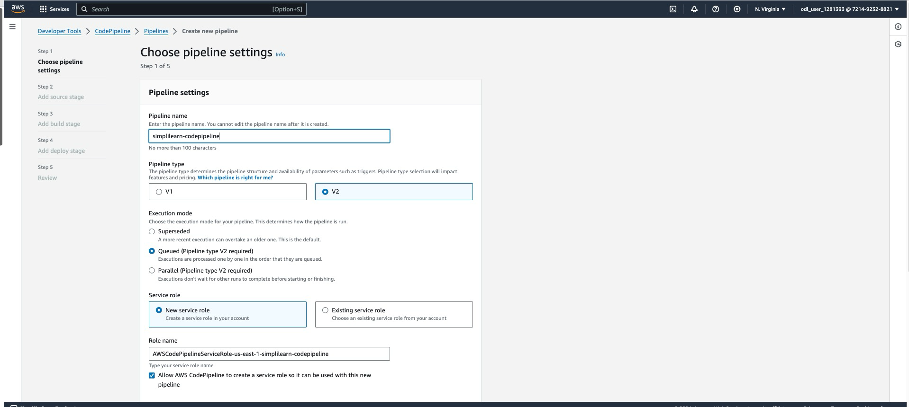

1. Specify artifact storage by selecting **Default location** or **Custom location** and set a bucket name, for example, **simplilearn-codebuild-artifact** with an option to use AWS-managed keys or a customer-managed key for encryption under the **Advanced settings** section

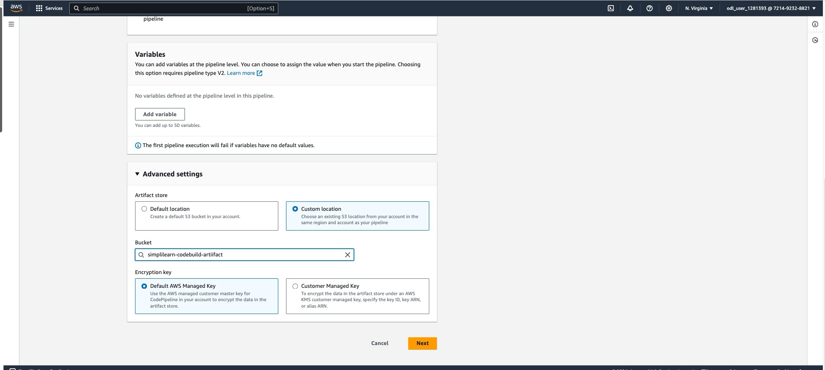

1. Select GitHub as your source provider, choose the repository **simplilearn** and the branch **master**, configure the change detection method using Amazon CloudWatch events or AWS CodePipeline to automate pipeline triggers on source updates, and select the output artifact format suitable for your needs

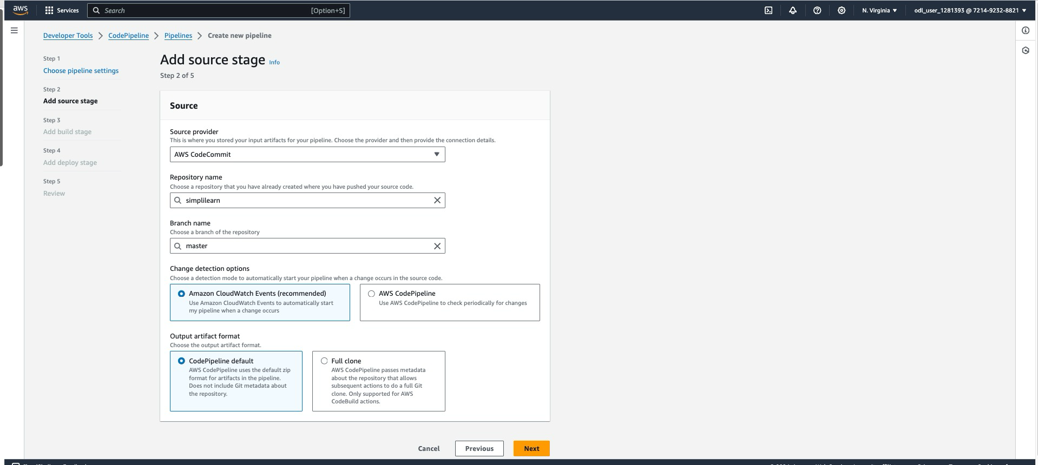

1. Select AWS CodeBuild as the build provider, specify your previously configured build project named **simplilearn-clone-build**, set any required environment variables, and choose between a single build or a batch build to execute per your deployment needs

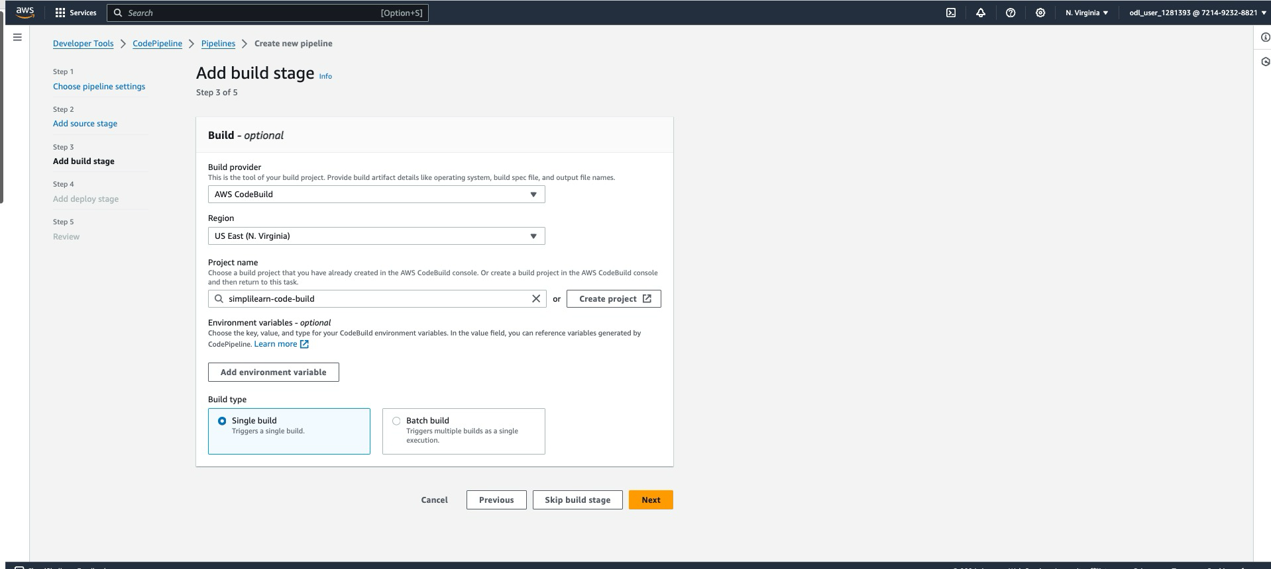

Ensure the below policies are attached to the CodePipeline service role, or else the pipeline may fail

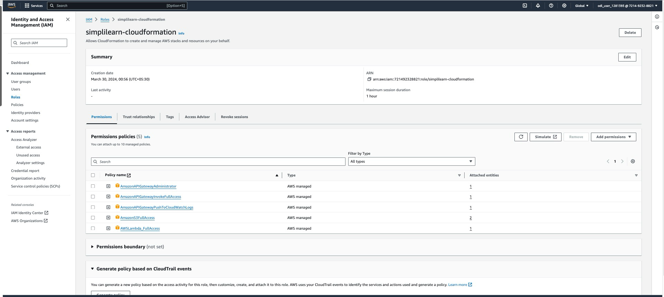

1. In the AWS CodePipeline interface, view the status of the pipeline stages, including Source, Build, and Deploy. Each stage shows as succeeded, indicating successful completion. To run the pipeline with new changes, click on **Release change** at the top right of the page.

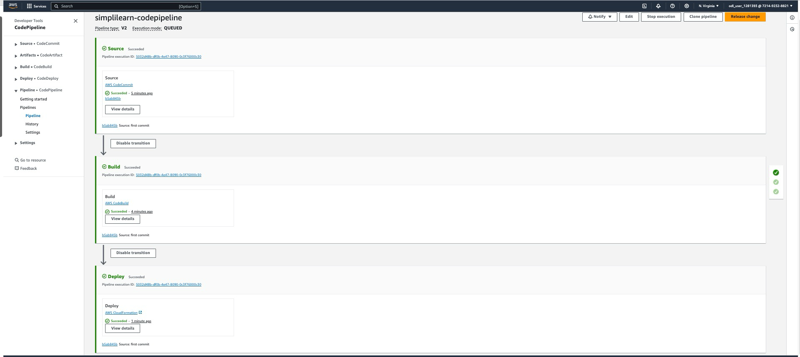

1. Modify the Build and Deploy stages in AWS CodePipeline by selecting **Edit stage** to configure settings in AWS CodeBuild and AWS CloudFormation or add actions and groups for detailed stage customization

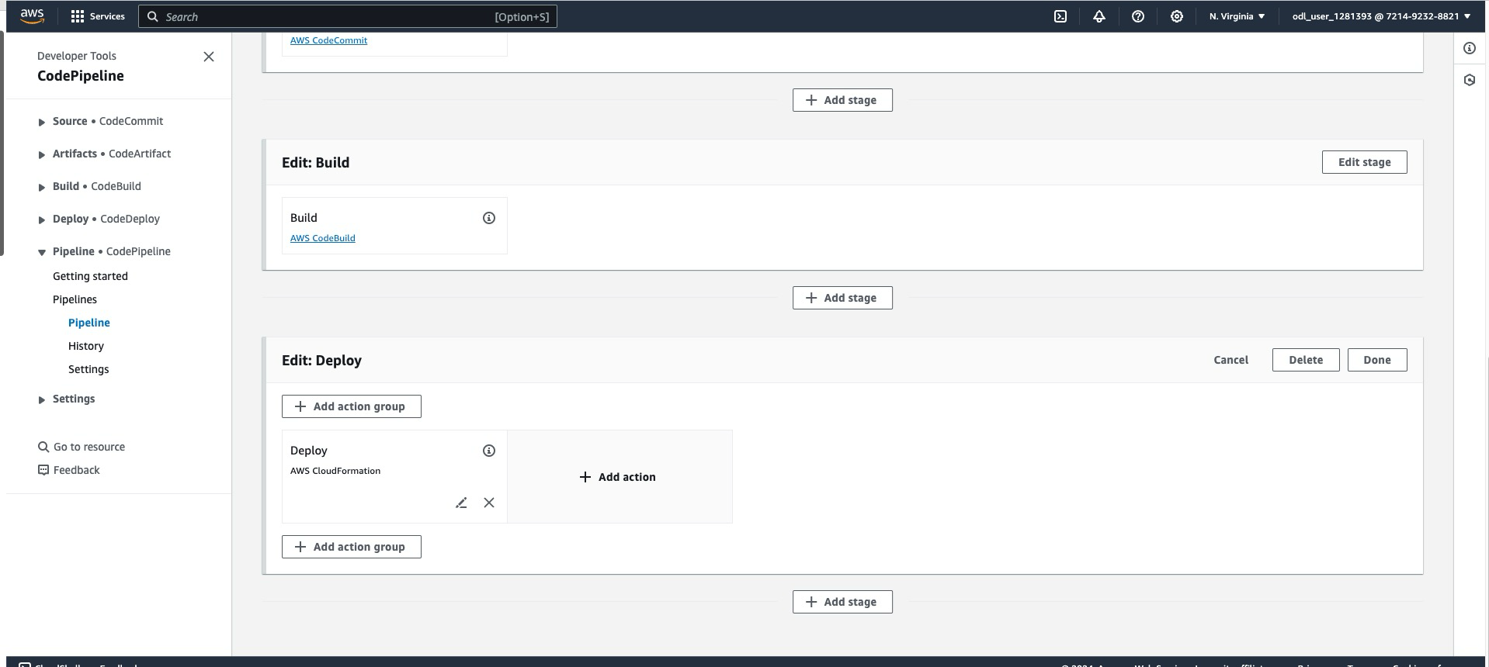

1. In the AWS CodePipeline, configure the CloudFormation action by entering an action name, selecting AWS CloudFormation as the provider, and choosing the appropriate AWS region. Link the **BuildArtifact** as the input artifact, set the action mode to **Execute a change set**, specify the stack and change set names, and, if necessary, define an output file name for the action results

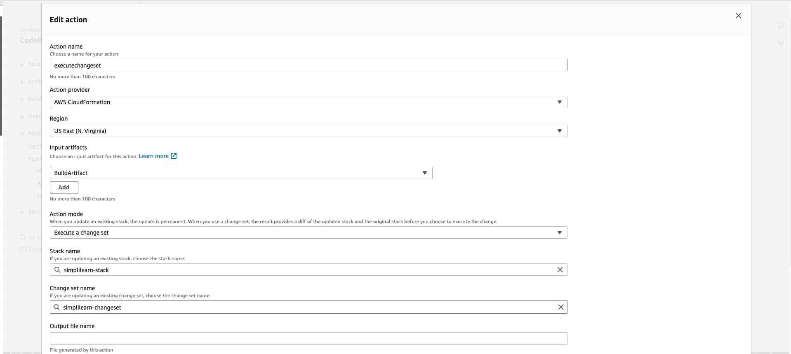

After the pipeline runs successfully, modify the code; the pipeline will automatically execute upon detecting these changes.

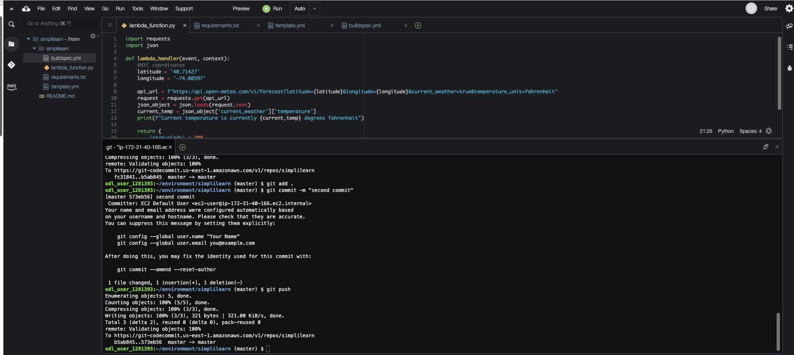

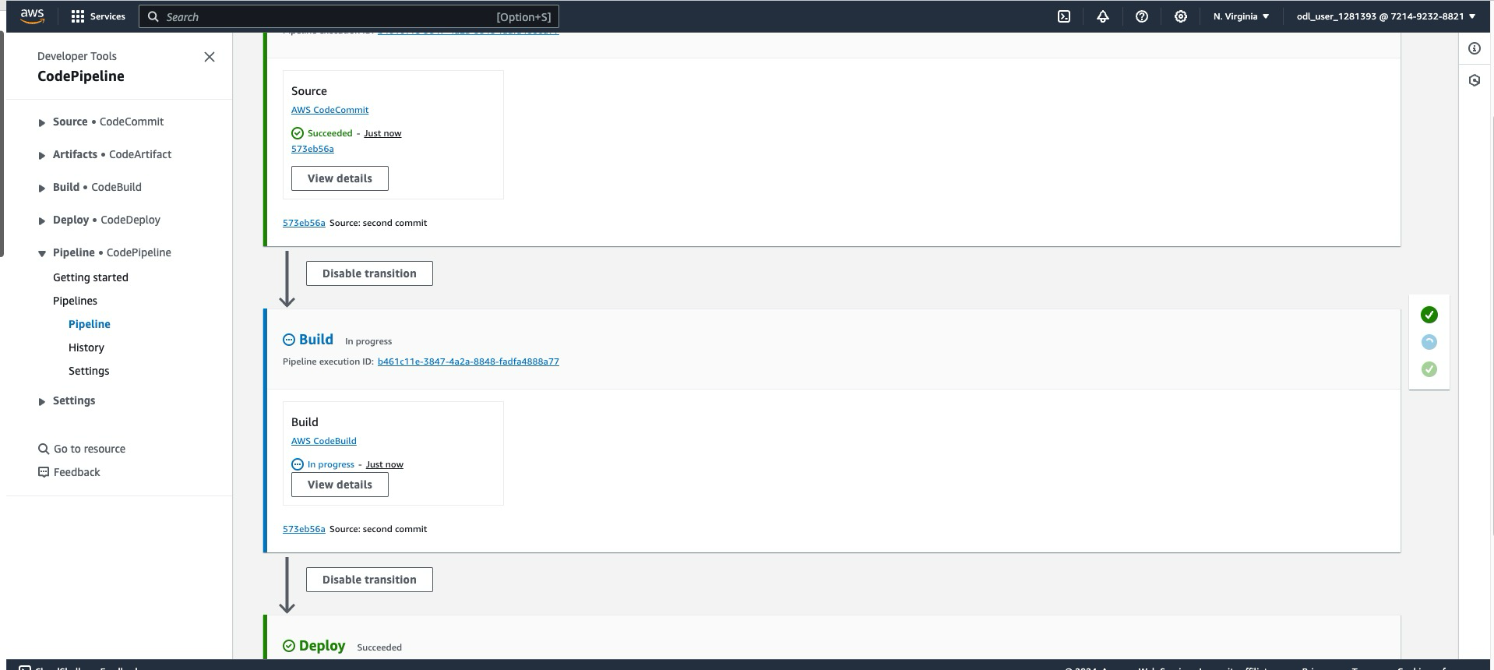

1. Click **+ Add action group** to create new groups, use **+ Add action** to define specific tasks, and click **Done** to save changes in the AWS CodePipeline Deploy stage

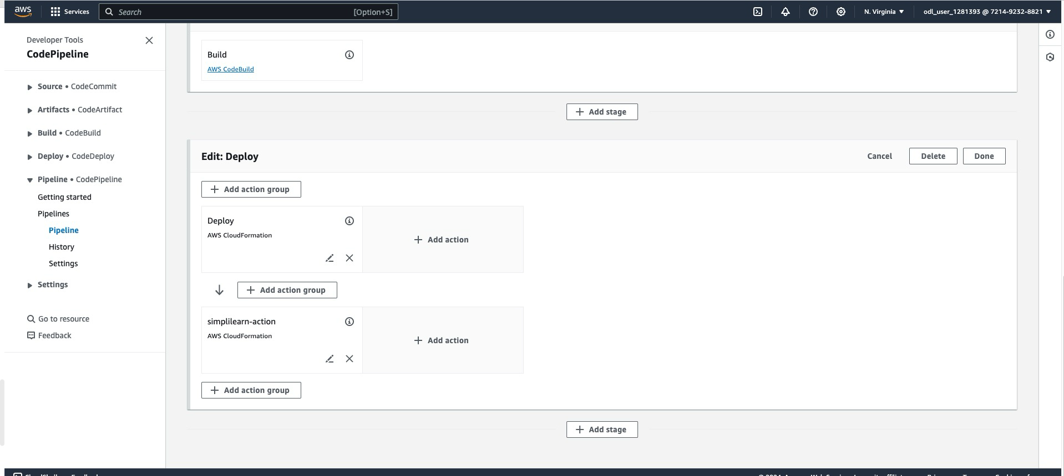

1. Enter **simplilearn-action** as the action name, select **AWS CloudFormation** as the provider, choose US East (N. Virginia) for the region, designate **BuildArtifact** as the input artifact, set the Action mode to **Execute a change set**, specify the Stack and Change set names, and save the changes

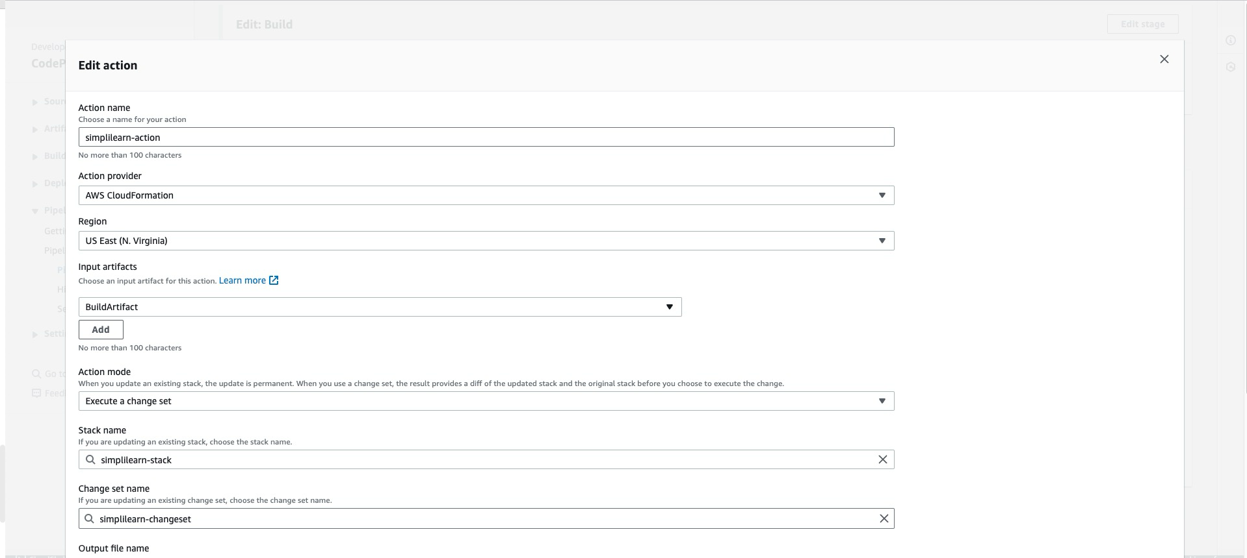

Once the stage is configured, tweak the pipeline by changing the code with any comment.

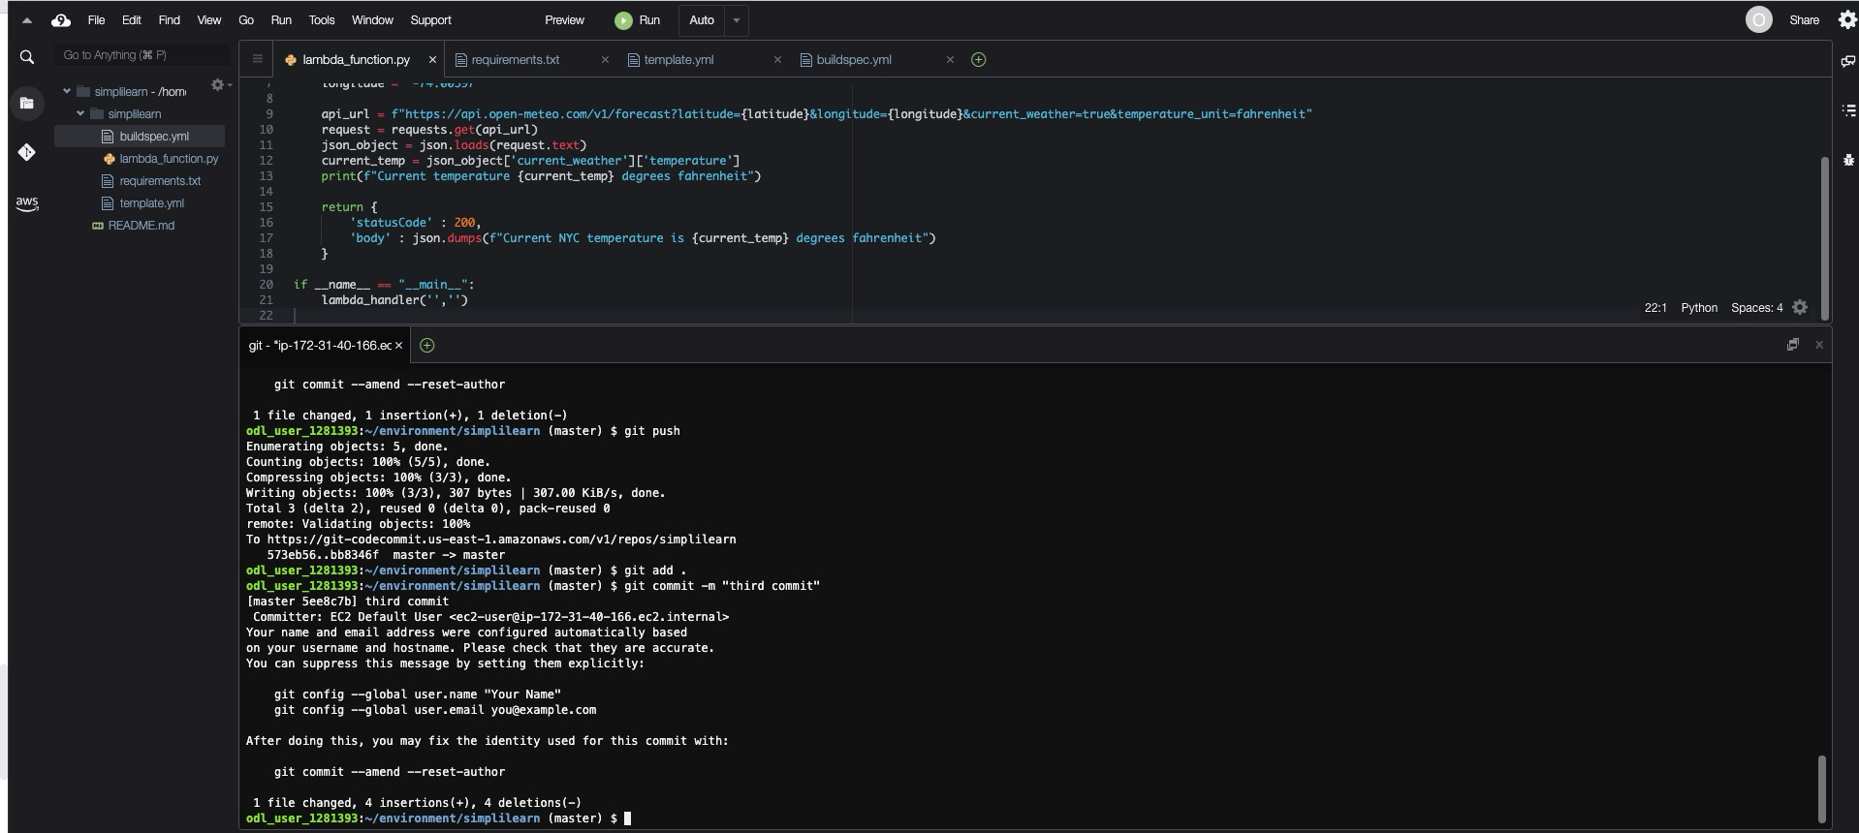

**Step 4:** **Test and validate functionality**

* 1. In Deploy stage, click on AWS-Cloudformation. It will open a new tab with details of stack deployments.

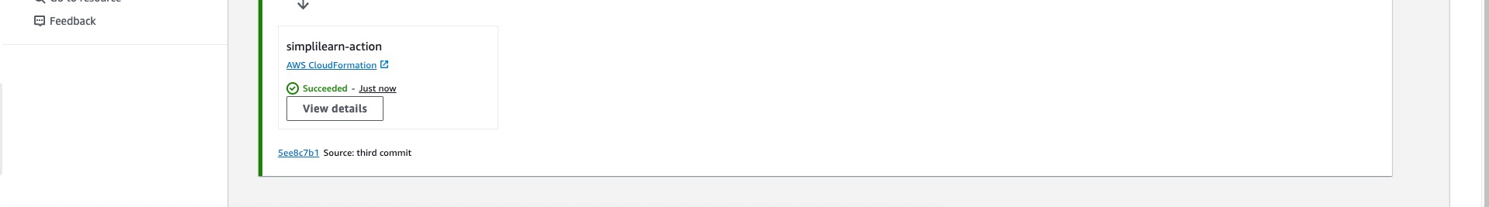

In this, you can see all the Resources Deployed by simplilearn-stack analyze the events occurred and logs associated to the stack.

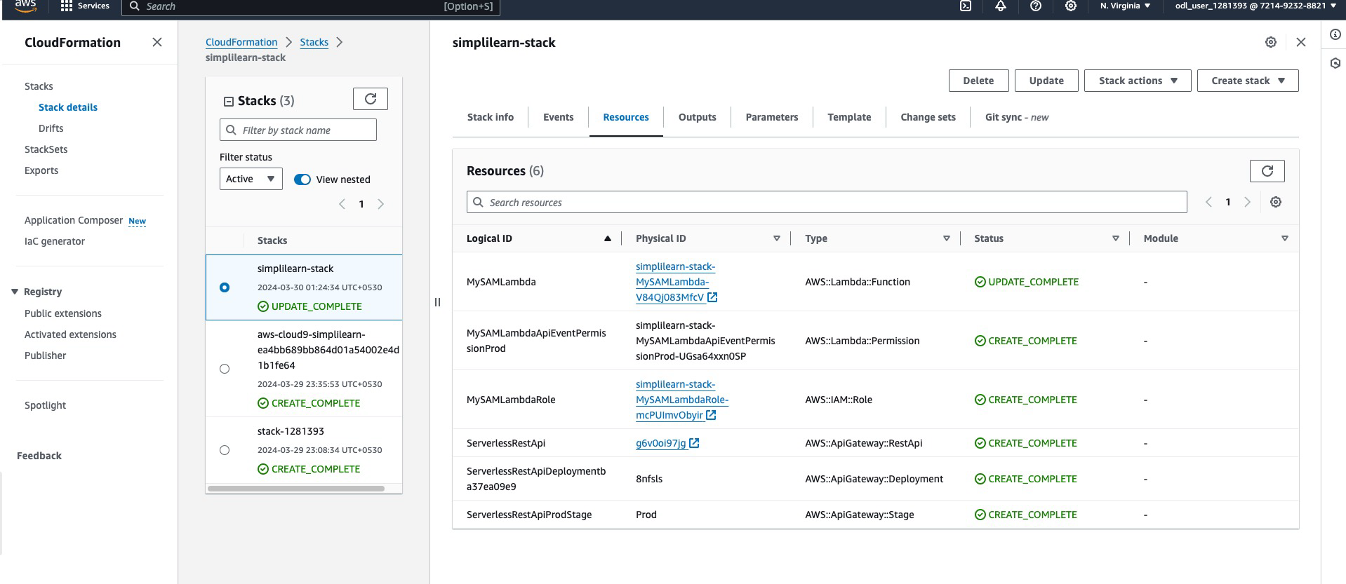

* 1. Click on Lamda. This will take you to Lambda console where you can verify if your lambda is deployed per the deployment specification passed



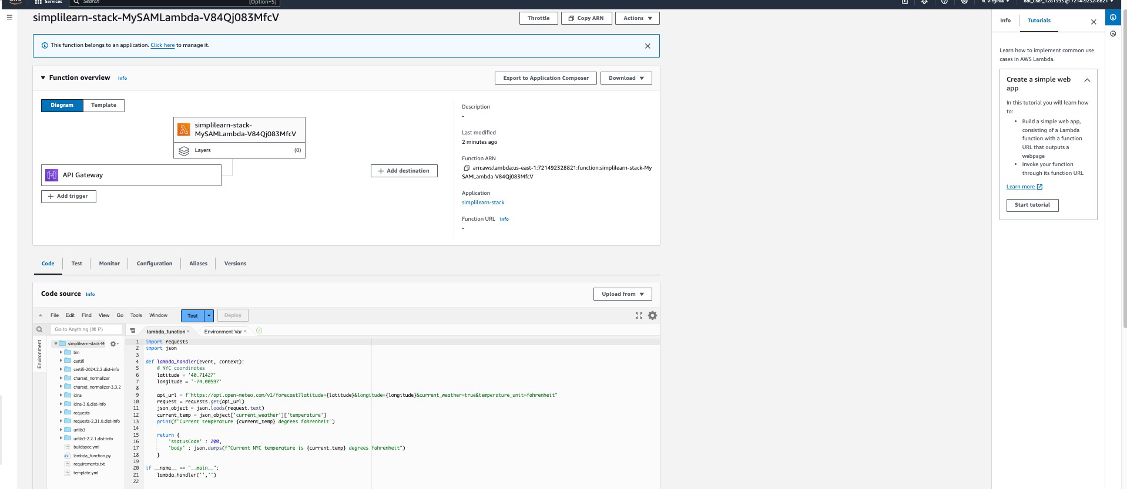

* 1. On Resource tab, click on RestApi resource. This will open the new tab to AWS API Gateway.



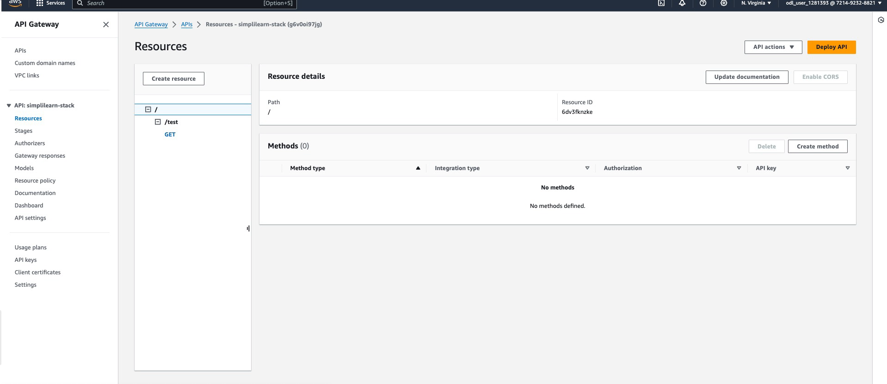

* 1. Click on Test. It will give you the Newark current temperature within the response header.

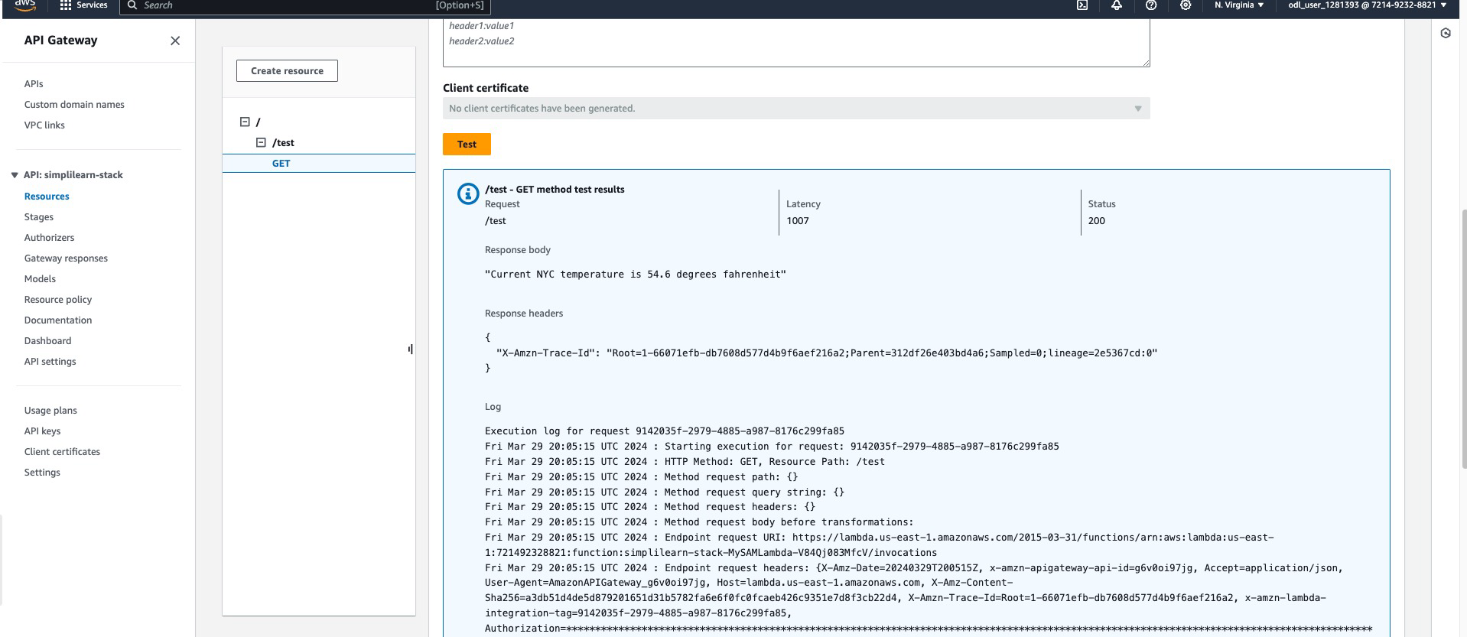

By following the above steps, you have successfully configured and deployed an AWS Lambda function using automated processes in AWS CodePipeline. This setup included setting up your development environment, developing and building your Lambda function, configuring the pipeline for continuous integration and delivery, and validating the functionality through various AWS services.